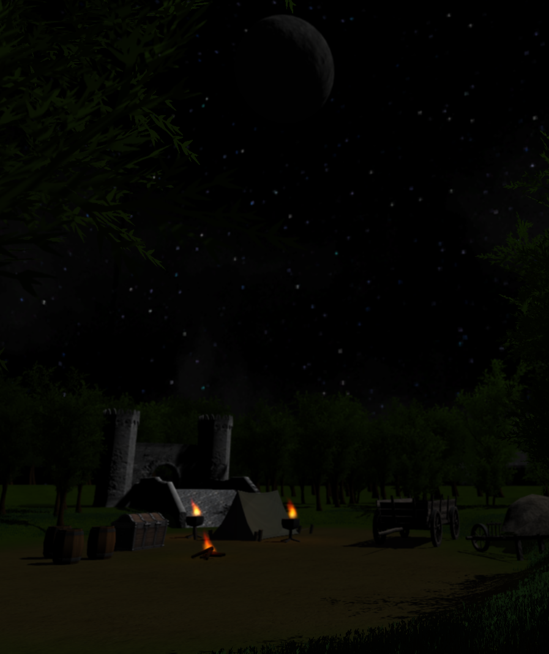

Project Evaluation

[Github Repository](https://github.com/wt-student-projects/level-design)

B00235610| 3D Level Design | 25/02/2017

Table of Contents

Critical Evaluation 2

Playtesting 2

Links 2

# Critical Evaluation

The first success of this project was how I structured it. As I decided to tackle the coursework individually it meant I had a work schedule that was perfect for me. It allowed me to have more flexibility with planning and allocations of work. This was critical as when it came to issues that I will explain later I could deal with them by allocating additional work sessions to deal with issues I encountered. This did bring disadvantages though as I had to deal with all work as it wasn’t spread across multiple individuals but either way complete control of the project in my view was best due to my tight workloads.

So, what did I accomplish? I completed the entire design as specified in the document and went above this in some areas as well. For instance, I tried to make the level loo as professional as possible by adding a menu, splash screen and showcase scenes. The level is immediately repayable as is professional demonstration.

There were several issues with the project thought. Firstly, the Unity version found in the labs did not meet the version that I used on my laptop stopping me from loading the project in Unity in the labs which was an issue. This meant that all testing had to be done by building an executable and then running it on the lab systems for testing which wasn’t productive.

I learned a lot in the project. Firstly, I learned a lot more experience with the Unity game engine which I think was a fantastic experience. Not only is it a popular engine it has a diverse range of features which means knowing this engine will allow me to do more. I also got to utilise C# as well, which is the default scripting language for Unity. This was another great thing to get experience with, as C# is a very popular language and being able to use it in unity will certainly aid me in my professional skillset.

In conclusion, despite some initial problems with hardware and software support in the labs this project was a success. Not only does the result meets the specification set out in the first design report but it is a great portfolio piece. I’m very happy with the output and it will certainly be something I maintain moving forward.

# Playtesting

## strategy

To test the result…

## Questionaire

This was the questionnaire.

## Response

This was the response

# Links

Executable: <https://github.com/wt-student-projects/3D-level-design>

GitHub: <https://github.com/wt-student-projects/3D-level-design>

Video: <https://www.youtube.com/watch?v=W81Bm0vSwzk>